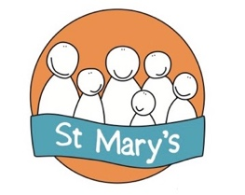
PCC of St Mary’s Sholing

Meeting Dates 2023/24

24th July 2023

11th September 2023

20th November 2023

29th January 2024

18th March 2024
29th April 2024
APCM followed by PCC Meeting to elect Officers

20th May 2024

22nd July 2024

16th September 2024

18th November 2024

Meeting held at St Mary’s Church
Prayer from 7pm with Meeting starting at 7:15

